**Lab 8: Advance Programming**

**Task 1:**

All codes provided in class lectures were simply practiced.

**Task 2:**

**Timer.js**

const React = require('react')

class Timer extends React.Component {

constructor(props){

super(props)

this.state = {

time: ''

}

this.startTimer = this.startTimer.bind(this);

this.handleChange = this.handleChange.bind(this);

this.handleSubmit = this.handleSubmit.bind(this);

}

startTimer() {

this.setState({time: this.state.time * 60});

this.timer = setInterval(() => this.setState({

time: this.state.time - 1

}), 1000)

}

clearInterval(){

}

handleChange(event) {

this.setState({time: event.target.value});

}

handleSubmit(event) {

event.preventDefault();

}

render() {

return (

<div>

<form onSubmit={this.handleSubmit}>

<label>

Input time in minutes:

<input type="number" value={this.state.value} onChange={this.handleChange} />

</label>

<input type="submit" value="Submit" />

</form>

{this.state.time <= 0 ?<h3>Time out!</h3> : <h3>time remaining: {this.state.time} seconds</h3>}

<button onClick={this.startTimer}>start</button>

</div>

);

}

}

export default Timer;

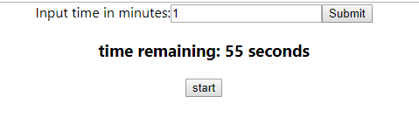

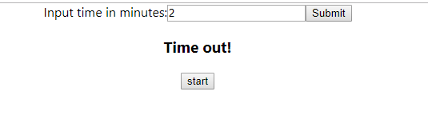

**App.js:**

import React, { Component } from 'react';

import logo from './logo.svg';

import './App.css';

import Timer from './Timer'

class App extends React.Component{

render(){

return (

<div className="App">

<Timer></Timer>

</div> );

}

}

export default App;